September 2, 2022

Legal Memorandum
_____________________________________

FCC Releases Order on FY 2022 Regulatory Fees

This afternoon (Friday, September 2), the Commission released its Report and Order and Notice of Inquiry (the “Order”) adopting a schedule of regulatory fees for the current fiscal year—i.e., Fiscal Year 2022 (“FY 2022”)—to be collected by the end of September 2022.

We are still reviewing the Order, and we will provide additional information in the coming days, including information regarding the actual FY 2022 reg fees payment due date (which the Commission typically announces in the days following release of the Order), how broadcasters can timely make their FY 2022 regulatory fee payments, and other important considerations.

Here, we provide some of the headlines from today’s Order.

As you’ll recall, the Commission’s proposed FY 2022 regulatory fees (which were released in June) contemplated a fee increase of approximately 13% year-over-year for radio and television stations. NAB, State Broadcaster Associations, other broadcasters, and even Members of Congress have advocated aggressively against those proposed fees in recent months, arguing that the proposed, large, year-over-year increase is inappropriate and cannot be justified.

Based on our initial review of the Order, it appears that the Commission has adopted FY 2022 regulatory fees for both radio and television licensees that are indeed higher than the FY 2021 regulatory fees—but that are lower than the approximately 13% fee increase that the Commission initially proposed. In other words, it would appear that broadcasters’ advocacy was at least somewhat successful.

The Order’s Regulatory Fee Amounts for Radio Broadcast Stations. Below, please find charts comparing the FY 2022 regulatory fees that were adopted in the Order released today as against FY 2021 regulatory fees for radio stations.
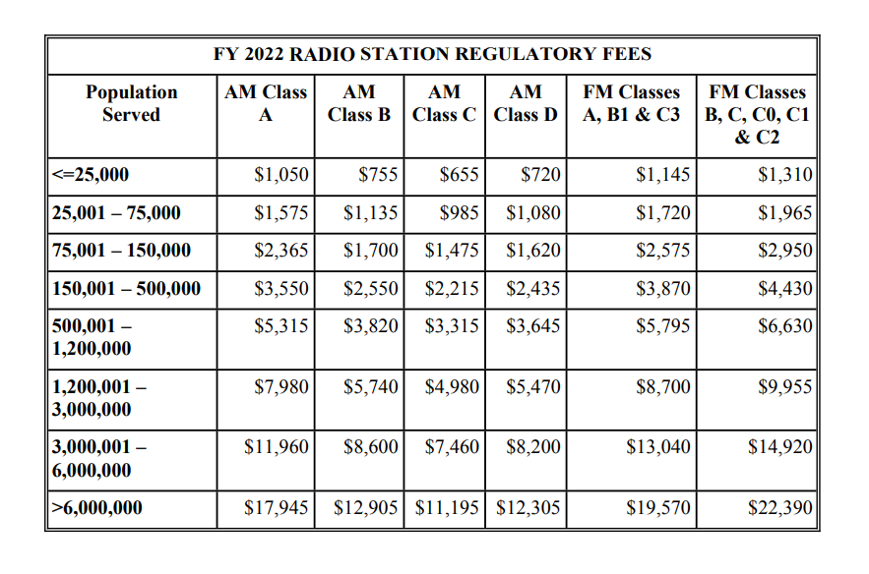
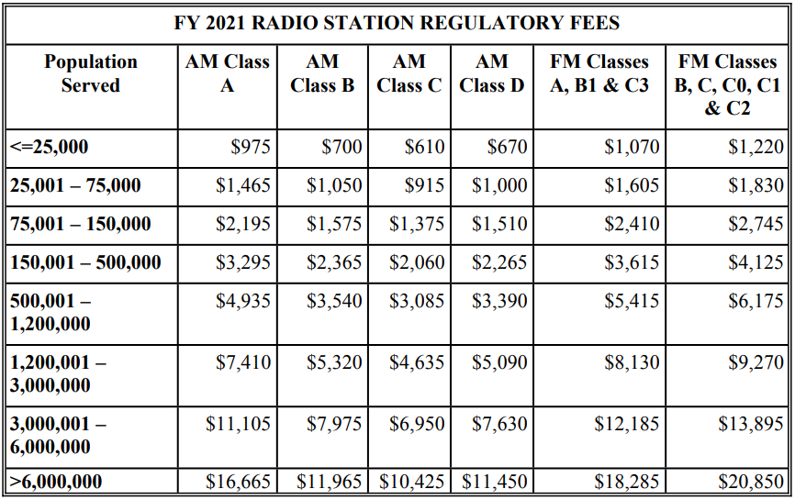
Population-Based Fees for Television Broadcast Stations. The Commission will continue to assess fees for full-power broadcast television stations based on the population covered by a full-service broadcast station’s NLSC. The current methodology operates by calculating fees using the population covered by the station’s projected NLSC, multiplied by a factor derived by taking the revenue amount required from all television fee categories and dividing it by the total population count of all “feeable” call signs. For FY 2022, the Commission initially proposed adopting a factor of .88 of one cent ($.008803) per person served within a full-service broadcast station’s NLSC; the Order, however, lowers that factor to .84 of one cent ($.008430) for each full-power broadcast television station. The Order’s $.84 of one cent factor is an increase over the $.78 of one cent ($.007793) factor used in FY 2021; as mentioned, however, it is lower than the $.88 of one cent factor the Commission proposed back in June. Appendix G of the Order lists the relevant proposed fee information for each television licensee.
De Minimis Threshold. The Commission declined in the Order to increase the de minimis threshold above $1,000. Broadcasters may recall that, under the Communications Act, if the Commission determines that the cost of collecting a regulatory fee would exceed the amount being collected from a party, the Commission is permitted to exempt that party from paying regulatory fees. Since 2017, the Commission has estimated that the cost of such processes exceeds $1,000 on average and that therefore the de minimis threshold should be set at the $1,000 level. Today’s Order keeps the de minimis level at that same, $1,000 amount; the Commission did not raise the existing threshold.

* * * * *

As mentioned, we will provide additional information regarding FY 2022 regulatory fees in a forthcoming memorandum.
___________________________

Tim Nelson, Editor

BROOKS, PIERCE, McLENDON,
HUMPHREY & LEONARD, L.L.P.
Mark J. Prak
Marcus W. Trathen
David Kushner
Coe W. Ramsey
Stephen Hartzell
Julia C. Ambrose
Elizabeth E. Spainhour
J. Benjamin Davis
Timothy G. Nelson
Patrick Cross
Noah Hock
Micole Little
___________________________________
This Legal Review should in no way be construed as legal advice or a legal opinion on any specific set of facts or circumstances. Therefore, you should consult with legal counsel concerning any specific set of facts or circumstances.
___________________________________

© 2022 Brooks, Pierce, McLendon, Humphrey & Leonard, L.L.P.

