August 27, 2021

*Special C-Band Reimbursement Memorandum*

Lump Sum and Actual Cost Reimbursement Status Update, and

How to Get Set Up for Reimbursement

With the C-band transition process now well underway, we write with a status update regarding reimbursement opportunities for broadcasters with qualifying, incumbent earth stations (i.e., C-band downlink and/or uplink dishes) and guidance regarding the initial steps necessary to get set up for such reimbursement. Importantly, we’ve received reports that broadcasters who elected lump sum reimbursement are now beginning to be able to submit reimbursement claims for review. We’ve also received reports that reimbursement funds may begin to be dispersed by mid-October. Given those reports, it may well be advantageous for broadcasters to ensure that they are all set up to submit (and, hopefully, soon receive!) such reimbursements. This is a long memo, and it contains important “how to” information, so we encourage you to keep reading.

Background. Following a 3-2 vote along party lines at its February 2020 Open Meeting, the Commission released a final Report and Order (the “Order”) aiming to make a significant portion of the C-band available for new terrestrial wireless uses as quickly as possible via auction, while also preserving the continued operation of existing fixed satellite services (“FSS”) during and after the C-band’s transition. Broadcasters with earth stations satisfying various criteria were classified as “incumbents” for purposes of the transition, with such classification entitling the broadcaster to interference protection and reimbursement for actual reasonable costs incurred as a result of transitioning its earth station(s). As of this writing, qualifying incumbent C-band registrants and licensees have already faced several important C-band-related deadlines since the Order’s release, including the September 2020 deadline by which they had to choose whether to irrevocably elect lump sum reimbursement for all of their qualifying earth stations or, instead, retain the ability to seek their actual reasonable relocation costs for each qualifying earth station. Following those deadlines, the Commission conducted the C-band auction, which concluded in February 2021 with gross winning bids totaling more than a whopping $81.1 billion.
Current C-Band Transition and Reimbursement Status. The various Satellite Operators (the “SOs”) transitioning C-band services—i.e., the satellite operators who send video and audio programming to broadcasters’ earth station dishes—have elected to attempt to satisfy “accelerated” C-band relocation deadlines, including by performing various band clearing and repacking activities by December 5, 2021, and December 5, 2023. Given that the first accelerated clearing deadline is now only a few months away, many broadcasters have already been contacted by—and have been working with—their SO or SOs as part of the relocation process.

At the same time, various administrative processes are underway to implement the mechanisms necessary for broadcasters (and others) to begin receiving reimbursement payments. Indeed, over the last several months the Relocation Payment Clearinghouse (the “RPC”)—which, among other things, is the entity overseeing collections into and distributions from the C-band Reimbursement Fund—the Relocation Coordinator, RSM US, LLP (“RSM”), and third-party contractors associated with the RPC and RSM have been contacting broadcasters to request that they establish an account in the “Coupa” reimbursement system. Successful registration in the Coupa system is a necessary first step to ultimately obtaining reimbursement, regardless whether you have elected to accept lump-sum elections or actual reasonable relocation costs. Once broadcasters establish their Coupa account, they may then begin to submit reimbursement “claims” for lump sum or actual cost reimbursement.

We have received informal guidance from the RPC that reimbursement for lump sum elections are likely to be fulfilled first—i.e., prior to actual cost reimbursements.

How to Prepare for Reimbursement. As indicated above, we have recently received reports that the RPC has begun to accept claims made through the Coupa system. Accordingly, below we hope to provide guidance to broadcasters who are in (or will soon begin) the process of registering in the Coupa reimbursement system—the necessary prerequisite to submitting reimbursement claims. The Coupa setup process is confusing, in part because the Coupa Portal is designed for general business use, rather than built specifically for the C-band reimbursement process. As a result, the Coupa system uses terminology and requires completion of certain fields that are unrelated to the C-band reimbursement process. However, broadcasters must understand those “unique” Coupa terms and fields in order to successfully register for reimbursement.

***PLEASE NOTE: We encourage you to consult with your Communications Counsel regarding your own specific factual circumstances prior to starting the Coupa setup process.

According to the RPC, reimbursement is expected to flow according to the following chart:

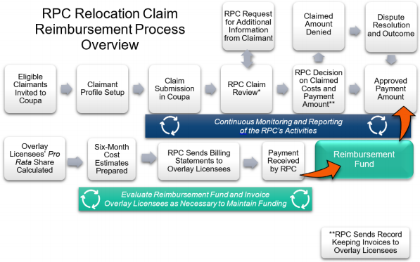

Definitions. First, it is useful to review and become familiar with the following definitions that are generally used throughout the Coupa reimbursement system and the RPC’s informational materials:

ESO Earth Station Operator (e.g., broadcasters with C-band downlink dishes)
IB FCC’s International Bureau
IBFS FCC’s International Bureau Filing System
Incumbents Definition includes broadcasters with qualifying, incumbent earth stations
Overlay Licensee Definition includes winners of the February 2021 C-band auction
RPC Relocation Payment Clearinghouse LLC
SSO Space Station Operator (i.e., Satellite Operator or “SO”)
WTB FCC’s Wireless Telecommunications Bureau
POC Point of contact for a broadcaster for purposes of the Coupa system
**Supplier This term is in the Coupa system only, and refers to broadcaster “claimants”—i.e., those seeking reimbursement through Coupa
**Customer This term is in the Coupa system only, and refers to the RPC

Available Resources. Below are links to resources that may be useful as you navigate the C-band reimbursement process:

RPC Reimbursement “Handbook”: As of this writing, the current version of the RPC reimbursement “Handbook” is version 1.1 and is available at the following link: https://cbandrpc.com/guidance/Resources/RPC_C-BAND_HANDBOOK_(VERSION_1.1).pdf.
Coupa Claimant Account Setup User Guide: https://cbandrpc.com/guidance/Resources/EXTERNAL_Coupa_Account_Setup_User_Guide_V2.1_07282021.pdf. This Setup Guide is referenced at times throughout the setup process and in the Handbook. Please note that this Setup Guide may be regularly updated, which means that you should therefore check for the latest version on the RPC’s website or the Coupa system.
RPC “Resources” Page: https://cbandrpc.com/resources/. As of this writing this page has information regarding how to initiate the Coupa setup process, as well as the current version of the Handbook.
RPC Coupa Setup Webpage: https://cbandrpc.com/setup/. As of this writing this page has information regarding the particulars of actually registering within the Coupa system, as well as links to important resources such as the “Authorization to Submit Claims Form,” which is required to successfully complete the Coupa setup process. This page also has user guides for lump sum and actual cost reimbursement claim submissions.
General RPC Webpage: https://cbandrpc.com/.
RPC Contact Information: You may contact the RPC either via email or telephone with questions regarding the reimbursement process:
Phone: (301) 463-4676 (available Mon. to Fri. from 8:00 a.m. to 5:00 p.m. ET)
Email: info@CbandRPC.com
Coupa Portal Landing Page: https:/supplier.coupahost.com/home

General overview for Coupa setup. At a high level, the Coupa setup process should follow the following flow:

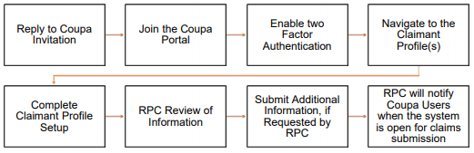

As of this writing the RPC has been conducting reimbursement outreach to broadcasters with qualifying incumbent earth stations, generally by transmitting an email requesting that the broadcaster initiate the process necessary to set up an account within Coupa. However, if you have not yet been contacted by the RPC and you believe you are eligible to submit a claim under the C-band relocation program, you may send an email to info@CbandRPC.com with: (1) “SETUP” in the subject line and (2) the following information in the body text:

- Name of broadcast entity/earth station registrant or licensee;
- Point of contact (POC) (must be someone with authority to make binding financial decisions for the earth station registrant/licensee);
- Title and/or position of point of contact;
- Email address for point of contact; and
- Phone number for point of contact.

Once the RPC responds and invites you to register in Coupa, you will then be required to input certain information in order to set up your reimbursement account. As of this writing, the RPC is requiring the following information for all broadcasters:

1. Email
2. Business Name
3. Contact Person’s Name and Phone Number
4. Address
5. Letter/document identifying personnel authorized to submit claims on behalf of claimant (i.e., the “Authorization to Submit Claims Form”)
6. Federal Tax Identification Number (TIN) / Employer Identification Number (EIN)
7. Bank Information (name, address, account, and routing number(s)) for Reimbursement
8. W-9
9. Business License
10. FCC License/Registration
11. Tax Exemption Certification, if applicable

Although some of the foregoing information will be prepopulated in the Coupa system, you should verify both (1) the accuracy of that information and (2) that all necessary information appears in the relevant fields. Please also note that most information must be “harmonized” across all fields. By way of example, the address listed on your business license must match the address on your W-9.

Although this memorandum does not comprehensively treat every step of the Coupa setup process, in our experience thus far broadcasters have had difficulty/questions with the following aspects of the process:

(1) Initially Joining the Coupa Portal:

The initial page that greets you when you click on the link to establish a Coupa profile is fairly straightforward. However, it has two fields—“Department” and “Role”—that must be completed but are unrelated to the C-band reimbursement process. The RPC has directed that you complete those fields by selecting “Other” and inputting “C-band Relocation” as follows:

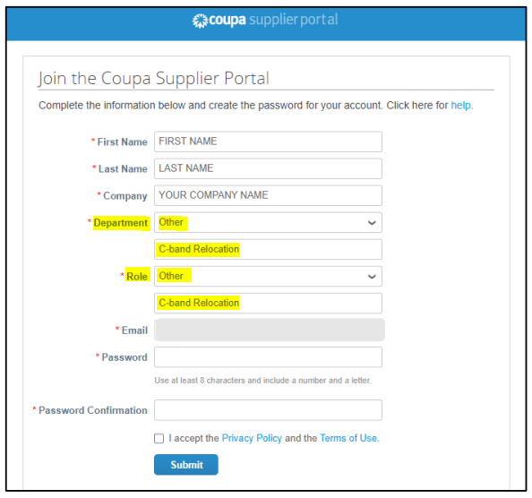
(2) Completing Coupa Information Requests:

One of the primary places where you must provide information is under the “Profile” / “Information Requests” tabs:
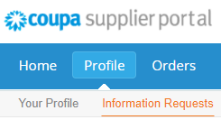

Selecting the “Information Requests” Tab should bring up the information page excerpted below. We have added our annotations in red below to target the areas about which we most often receive inquiries:

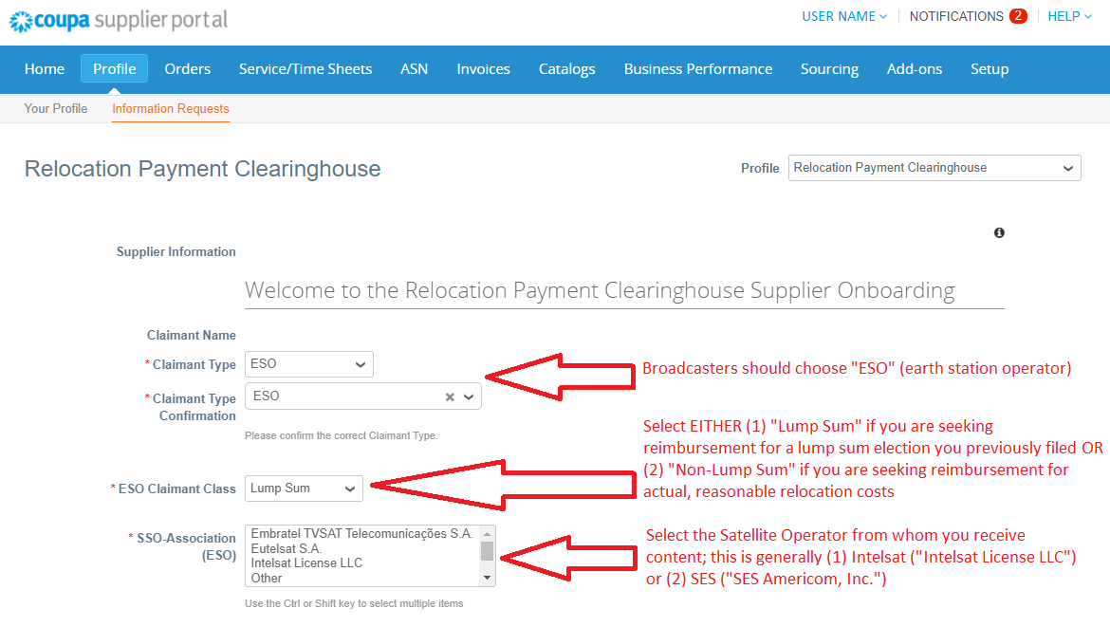

* * * * *

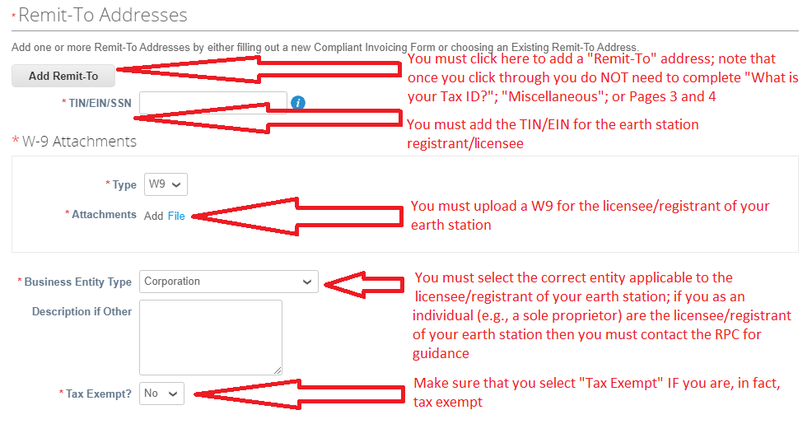

* * * * *

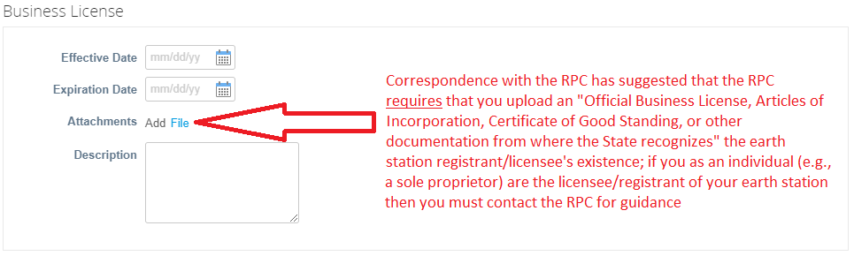

* * * * *
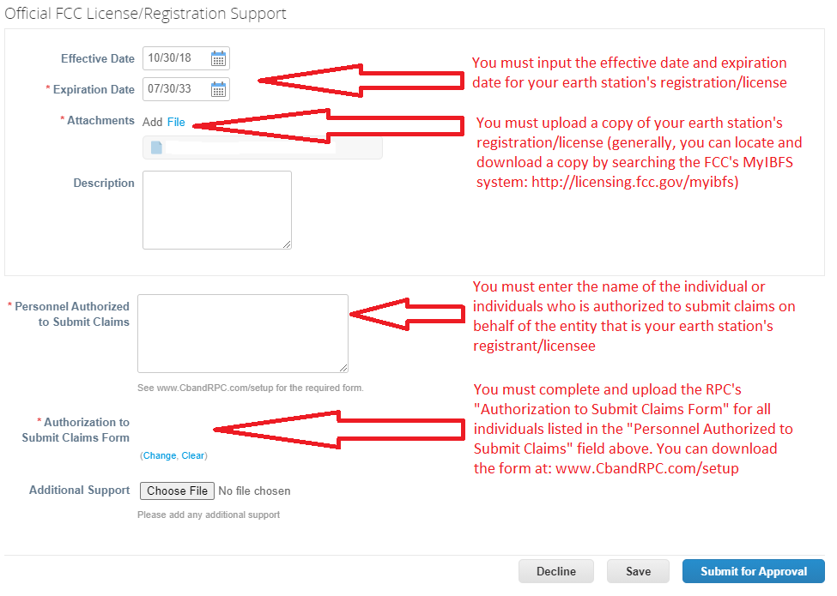
* * * * *

(3) Completing Coupa Banking Information:

You must separately navigate to the “Banking Information” page by choosing “Setup” / “Admin” / “Add Remit-To” from the Coupa main page:

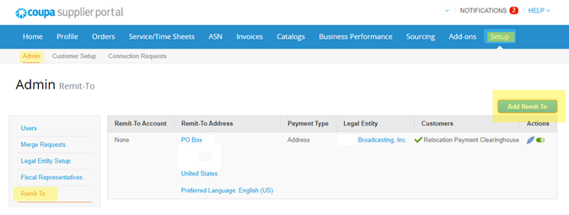

Fill in all required financial information in order to complete setup (although note that a “SWIFT CODE (BIC)” is not required to complete setup and therefore should be left blank). NOTE: The account you provide will be the account through which you receive reimbursement (if eligible), and the Coupa reimbursement system can only store one bank account. Accordingly, please ensure that you input information regarding the correct account.

* * * * *

(4) Items NOT to Complete: As noted above, the Coupa system is designed for general business use, rather than built specifically for the C-band reimbursement process. Accordingly, you will receive various prompts to complete additional sections that are entirely inapplicable to the C-band relocation reimbursement process, even despite the fact that some of them suggest that by inputting additional information you may “get paid faster.” Some of those additional sections may also be public facing and, therefore, searchable online. Here is a brief list of sections that you do NOT need to complete:

- NOT NEEDED TO COMPLETE: “Improve Your Profile.”

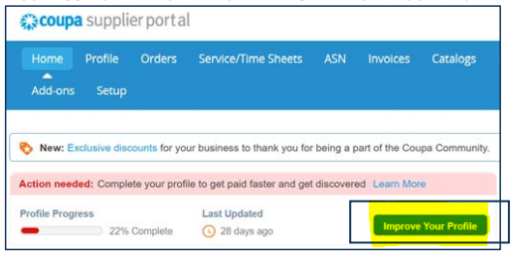

- NOT NEEDED TO COMPLETE: “Action Needed—Complete Your Profile to Get Paid Faster and Get Discovered.”

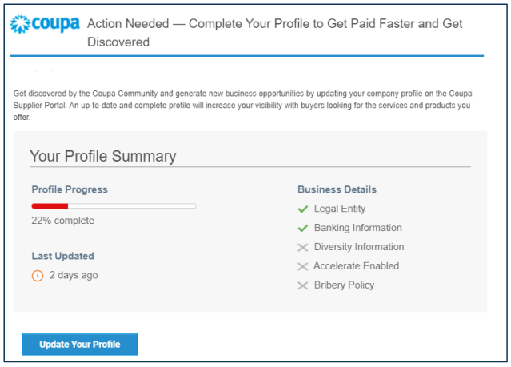

Additionally, note that clicking on “Chat with Coupa Support” will NOT connect you with the RPC but instead will connect you with Coupa’s independent support staff who will be unable to assist you with C-band relocation reimbursement (believe us—we’ve tried!):
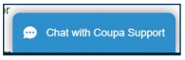

* * * * *

We hope this has provided some guidance and insight into the C-band relocation reimbursement process generally, as well as the specific steps broadcasters with qualifying, incumbent earth stations should be taking to set themselves up for reimbursement.

Once you have successfully set up your Coupa account, the RPC has indicated that—after some time—you should receive correspondence from Coupa stating that “Your RPC Profile is Ready for Claims Submission.” We strongly encourage you to consult with the applicable RPC Guides (including the “Lump Sum Claim Submission User Guide” and “Actual Cost Claim Submission User Guide,” as applicable) for further information on actual claim submissions. And, of course, we encourage you to consult with your Communications Counsel regarding your own specific factual circumstances prior to beginning the Coupa setup or reimbursement claim submission processes.
___________________________

Tim Nelson, Editor

BROOKS, PIERCE, McLENDON,
HUMPHREY & LEONARD, L.L.P.
Mark J. Prak
Marcus W. Trathen
David Kushner
Coe W. Ramsey
Stephen Hartzell
Julia C. Ambrose
Elizabeth E. Spainhour
J. Benjamin Davis
Timothy G. Nelson
Patrick Cross
___________________________________
This Legal Review should in no way be construed as legal advice or a legal opinion on any specific set of facts or circumstances. Therefore, you should consult with legal counsel concerning any specific set of facts or circumstances.
___________________________________

© 2021 Brooks, Pierce, McLendon, Humphrey & Leonard, L.L.P.

