May 12, 2021

Legal Memorandum

In this issue, please find information about

Headlines: | FCC Issues Notice of Proposed Rulemaking on FY 2021 Regulatory Fees  FCC Adopts Report and Order Requiring Foreign Sponsorship ID, Despite Broadcaster Opposition  FEMA Schedules National EAS Test for August 11, 2021  Media Bureau Dismisses Broadcaster’s Carriage Complaint  Remaining All-Digital AM Rules Take Effect

FCC Issues Notice of Proposed Rulemaking on FY 2021 Regulatory Fees

Last week, the Commission released a Report and Order and Notice of Proposed Rulemaking (the “Notice”) that contemplates proposed regulatory fees for Fiscal Year 2021 (“FY 2021”). The most significant items to broadcasters in the Notice (beyond the proposed fees themselves, of course!) on which broadcasters may wish to comment are: (1) the Commission’s proposal to “refine” the new (as-of last year) methodology to calculate full-power television stations’ regulatory fees based solely on population, and (2) whether the FCC should extend the streamlined waiver provisions it adopted last year in light of the COVID-19 pandemic.

PLEASE NOTE: All the fee amounts discussed below are currently just proposals set forth in the Notice. It is possible that the proposed fees may change prior to the FCC’s formal FY 2021 Regulatory Fees Order.

The Notice’s Proposed Regulatory Fee Amounts for Radio Broadcast Stations. Based on a review of the Notice, when it comes to the proposed FY 2021 regulatory fees for radio broadcast stations, it appears that most radio stations would see a fee increase of between 6% to 8% if the Notice is adopted as currently drafted. Below please find a chart comparing the FY 2020 regulatory fees that were ultimately adopted for radio stations, followed by the Notice’s proposed FY 2021 radio station regulatory fees.

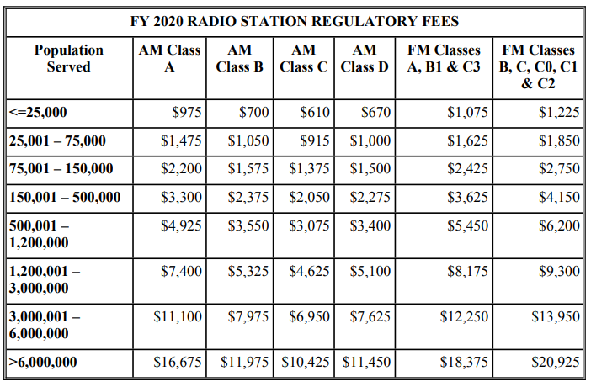
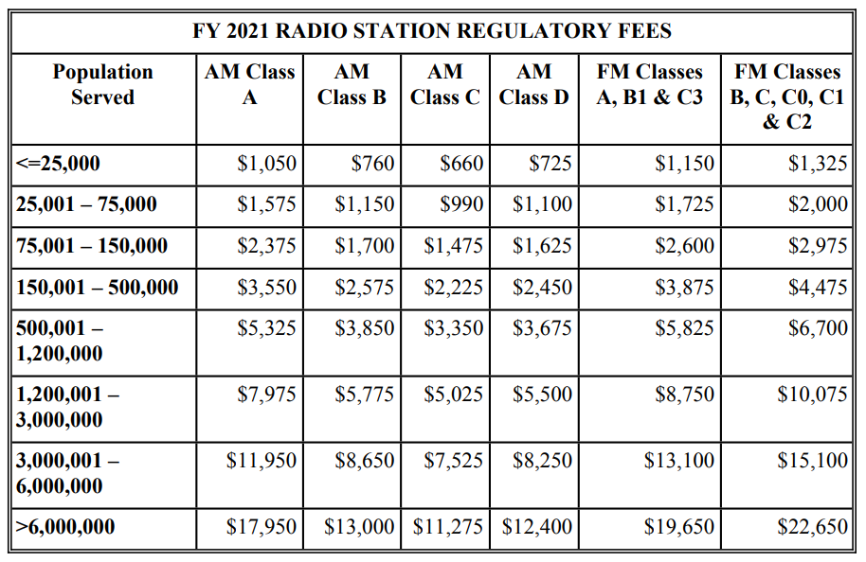

Proposed Population Tiers for Television Broadcast Stations. Until recently, regulatory fees for television broadcast stations were assessed based on the market served by a given station, as defined by Nielsen Designated Market Areas (“DMAs”). Three years ago, however, the FCC adopted a new methodology for assessing regulatory fees for full-power broadcast television stations in 2019 and beyond. The “new” methodology bases fee calculations on the actual population covered within the station’s noise limited service contour (“NLSC”), instead of DMAs. You may recall that, in order to facilitate the transition to this “actual population” fee structure, the FY 2019 regulatory fees were “blended”—that is, the FY 2019 fees were based partly on the historical DMA methodology and partly on the new population-based methodology. Then, last year (FY 2020), the Commission used the population-based methodology exclusively.
Now, for FY 2021, the Notice solicits comment on the Commission’s continued use of the “actual population” methodology to assess fees. For those interested in getting into the weeds here, that methodology calculates fees using the population covered by the station’s projected NLSC, multiplied by a factor “derived by taking the revenue amount required from all television fee categories and dividing it by the total population count of all ‘feeable’ call signs.” This year, the proposed multiplication factor is $0.008525, which is slightly higher than the FY 2020 multiplication factor. You may wish to consult the Notice’s comprehensive appendix (Appendix F) which lists all relevant proposed fee information for each television licensee. Based on our review, it appears that most television broadcasters can expect a fee increase ranging anywhere from several hundred to several thousand dollars (or more, in the case of certain broadcasters), assuming the proposals in the Notice are adopted as-is.

Looking forward to FY 2022, the Notice also solicits comment on streamlining the population methodology by dividing full-power television stations into population tiers, rather than calculating each station’s precise fee amount on a call-sign by call-sign basis. According to the Notice, “[t]he current process required to implement a per call sign fee calculation imposes a significant administrative cost on the Commission and a portion of fee payors.” Accordingly, the Notice seeks comment on “whether the administrative benefits for the Commission and fee payors of using a tiered table to establish television broadcaster regulatory fees would outweigh the costs and be easier for fee payors to navigate.”

Proposed Extension of COVID-19 Relief Related to Payment Flexibility. The Notice also seeks comment on whether the Commission should extend the various forms of relief it adopted for FY 2020 in response to the COVID-19 pandemic. Those forms of relief included:

- Not requiring separate filings for requests for fee waivers, reductions, deferrals, or extended payment terms (i.e., installment payment requests) for financial hardship, and instead accepting single submissions requesting any combination (or all) of the foregoing forms of relief.

- Reducing the interest rate the Commission charges on installment payments to an unspecified “nominal rate,” and waiving the typical requirement to provide a down payment in order to be eligible for installment payments.

- In recognition of the fact that “demonstrating financial hardship caused by the pandemic may require different financial documentation than the documentation the Commission has traditionally accepted,” directing the Commission to “work with individual[s]” who request relief to obtain any additional documents necessary to render a decision on the request.

- Partially waiving the FCC’s “red light” rule by allowing the FCC (though its Managing Director) discretion to permit regulatees with outstanding debts owed to the Commission to nonetheless request waivers, reductions, deferrals, and installment payment terms for fees. (Although, all regulatees for whom the red light rule is waived were required to resolve all delinquent debt currently owed.)

Comments on the Notice’s various proposals are due by June 3, 2021. Reply comments are due by June 18.
___________________________

FCC Adopts Report and Order Requiring Foreign Sponsorship ID,

Despite Broadcaster Opposition

Over opposition from the broadcast industry, the FCC last month unanimously adopted a Report and Order (the “Order”) to require specific, standardized disclosures relating to broadcast material paid for or provided by foreign governments and their representatives – what many are calling new “foreign sponsorship ID” rules. Broadcasters’ objections to aspects of the FCC’s initial proposal for the Order (released in October 2020) did, in fact, result in several modifications from the initial proposal; however, the 2020 proposal’s core disclosure and diligence obligations remain unchanged in the final Order. The Order’s new rules will supplement the existing sponsorship identification requirements that are applicable to broadcasters.

Please note: The new foreign sponsorship identification rules and obligations discussed below have not yet taken effect and still must undergo various regulatory approval processes. The timing of those processes is uncertain. We will monitor the rules’ progress through those processes and inform you of further significant developments regarding the rules’ effective date.

Background. The requirement for broadcasters to identify when programming material has been paid for, sponsored, or otherwise provided by someone other than the broadcaster predates the creation of the FCC. As early as 1927, Congress adopted legislation—addressing what we now colloquially call “sponsorship identification”—in an effort “to ensure that the public knew who had funded particular broadcast programming, without in any way censoring or prohibiting such programming.”

Over the years, Congress amended its 1927 legislation, and the Commission adopted and provided subsequent guidance regarding its own sponsorship identification rules. Currently set forth in both the Communications Act (as amended) and the FCC’s regulations and interpretive decisions, the sponsorship ID rules require—we suspect this will all sound familiar to broadcasters—that when a broadcast licensee has received or been promised payment or other consideration for the airing of program material, the station must disclose that fact at the time of airing and identify who paid for or promised to pay for the material. Under the current rules, stations also have the responsibility to exercise “reasonable diligence” in determining whether sponsorship identification is needed, and, if so, in identifying the true sponsor of the broadcast material.

Fast forward to October 2020, when the FCC issued a Notice of Proposed Rulemaking (the “Notice”) intended to “specifically target[] . . . situations where a station broadcasts material that has been sponsored and/or provided for free by a foreign government,” including by identifying the relationship of any programming sponsor to a foreign country. The Notice framed its proposals as responsive to recent incidents of undisclosed foreign broadcasts, such as U.S. broadcasts by “RT America”—a television news network funded and controlled by the Russian government—asserting that 5G services are a health hazard, despite the fact that Russia appears to be strongly promoting the launch of 5G in its own country.

Various broadcaster groups opposed aspects of the FCC’s proposal, including the significant new proposed diligence requirements for identifying and disclosing when content is sponsored by a foreign government or its representatives—and the burdens those requirements place on broadcasters.

The Order Generally. At a high level, the Order adopts rules that will require foreign sponsorship identification for programming content aired on a station pursuant to a lease of airtime if the direct or indirect provider of the programming qualifies as a “foreign governmental entity” as defined in the new rules. The underlined text above—“pursuant to a lease of airtime”—is a significant change from the FCC’s initial proposal, which contained no such distinction and instead sought to impose identification and disclosure obligations on all types of programming, no matter how received or broadcast.

Although the Order’s new rules contain too many nuances to concisely explain in this memorandum, below you will find information regarding several of the most significant adopted rules of which you should be aware.

Foreign Governmental Entity Definition. For purposes of the new rules, the Order defines a “foreign governmental entity” as an entity included in any one of the following categories:

- A “government of a foreign country” as defined by the Foreign Agents Registration Act (“FARA”);
- A “foreign political party” as defined by FARA;
- An individual or entity registered as an “agent of a foreign principal,” under section 611(c) of FARA, whose “foreign principal” is a “government of a foreign country,” a “foreign political party,” or is directly or indirectly operated, supervised, directed, owned, controlled, financed, or subsidized by a “government of a foreign country” or by a “foreign political party” as defined by FARA, and that is acting in its capacity as an agent of such “foreign principal”;
- An entity meeting the definition of a “U.S.-based foreign media outlet” pursuant to section 722 of the Communications Act that has filed a report with the Commission.

When Disclosure is Required. As noted above, the Order adopts a significant threshold condition necessary to trigger the disclosure requirement—the new rules’ disclosure obligations apply only when a foreign governmental entity is programming a U.S. broadcast station pursuant to the lease of airtime. Disclosure is also only necessary for political programming or programming discussing a “controversial issue.” Put differently, in the words of the Order disclosure is required “at the time of broadcast if material aired pursuant to the lease of time on the station has been sponsored, paid for, or, in the case of political program or any program involving the discussion of a controversial issue, if it has been furnished for free as an inducement to air by a foreign governmental entity.”

What constitutes a qualifying “lease”? According to the Order, a “lease” that would trigger the new disclosure obligations includes “any arrangement in which a licensee makes a block of broadcast time on its station available to another party in return for some form of compensation,” regardless “what those agreements are called, how they are styled, and whether they are reduced to writing.” For purposes of the new rules, the touchstone appears to be whether the “lease” gives “one party—the brokering party or programmer—the right and obligation to program the station licensed to the other party—the licensee or broadcaster.” Notably, the Order makes clear that its definition of a qualifying “lease” is not meant to encompass “traditional, short-form advertising,” but instead is focused on agreements by which a third party controls and programs a discrete block of time on a broadcast station.

What constitutes a qualifying “political program” or “controversial issue”? The new disclosure obligations also only apply to “political programs” or programs “involving the discussion of a controversial issue.” The Order does not provide a precise definition of “political program,” but indicates that the definition will track prior Commission precedent regarding the term and will “generally involve programming seeking to persuade or dissuade the American public on a given political candidate or policy issue.” As for the definition of a qualifying “controversial issue,” the Order indicates that determinations are necessarily made on a “case-by-case basis,” but generally involve issues that are the subject of debate and the presentation of opposing viewpoints within a community.

Is consideration required? The Order adopts the same “consideration” requirement that is currently necessary to trigger broadcasters’ general sponsorship identification obligations. That is, the new foreign sponsorship identification rules’ disclosure obligations will be triggered if any money, service, or other valuable consideration is directly or indirectly paid or promised to, or charged or accepted by a broadcast station in the context of a lease of broadcast time in exchange for the airing of material provided by a foreign governmental entity. (The Order also applies even if the only “consideration” being offered to the station in exchange for the airing of the material is the programming itself. However, as a practical matter the Order notes that this circumstance is unlikely to arise with much frequency given that “[i]t is not typical for a station to enter into an agreement for the lease of airtime in exchange solely for the promise of free programming to be aired on the station.”)

Diligence Required. Under the new rules, broadcast licensees must exercise “reasonable diligence” to determine if programming is being provided by a qualifying “foreign government entity” and triggers the disclosure obligations set forth above. In this regard, the Order imposes the following “minimum” diligence requirements:

- Inform the lessee at the time of the agreement and at renewal the agreement of the foreign sponsorship disclosure requirement.
- Inquire of the lessee at the time of agreement and at renewal whether the lessee falls into any of the categories that qualify it as a “foreign governmental entity”.
- Inquire of the lessee at the time of agreement and at renewal whether the lessee knows if anyone further back in the chain of producing/distributing the programming that will be aired pursuant to the lease agreement, or a sub-lease, qualifies as a foreign governmental entity and has provided some type of inducement to air the programming.
- Independently confirm the lessee’s status at the time of agreement and at renewal by consulting the Department of Justice’s FARA website and the Commission’s semi-annual U.S.-based foreign media outlets reports for the lessee’s name. This need only be done if the lessee has not already disclosed that it falls into one of the covered categories and that there is no separate need for a disclosure because no one further back in the chain of producing/transmitting the programming falls into one of the covered categories and has provided some form of service or consideration as an inducement to broadcast the programming.
- Memorialize the above-listed inquiries and investigations to track compliance in the event documentation is required to respond to any future Commission inquiry on the issue, and retain that documentation for the remainder of the then-current license term or one year, whichever is longer.

Notably, the foregoing diligence requirements do not include two of the more onerous obligations the Commission had proposed—a proposed requirement to conduct open-ended Internet searches to identify the lessee’s status and a proposed requirement that all the foregoing due diligence be performed every six months, rather than at the time of the agreement and at renewal.

Importantly, the Order expressly states that: “broadcasters may choose to implement these requirements through contractual provisions between the licensee and lessee though they are not required to do so.” The Order therefore appears to contemplate the idea that broadcasters could satisfy at least some of the diligence requirements outlined above by including sufficient language in the governing agreement with the lessor. Broadcasters may wish to contact communications counsel to determine whether to employ such an approach.

Additionally, broadcasters should note that the foregoing “reasonable diligence” requirements, once they take effect, will apply even to lease agreements that are currently in effect. Broadcasters will have six months from the date on which the new rules take effect to undertake the reasonable diligence steps outlined above.

Content and Frequency of Disclosure. Under the new rules, when the disclosure obligations outlined above are triggered, broadcasters must use standardized language to inform audiences at the time of broadcast that the program material has been provided by a foreign governmental entity, and they must promptly place copies of the disclosures in their online public inspection files (“OPIFs”), in a standalone folder marked as “Foreign Government-Provided Programming Disclosures.”

The Order generally specifies the following required disclosure language, which must be presented in the primary language of the programming:

“The [following/preceding] programming was [sponsored, paid for, or furnished,] either in whole or in part, by [name of foreign governmental entity] on behalf of [name of foreign country].”

Note that, where applicable, instead of using the foregoing language, broadcasters may pass through a label made pursuant to FARA’s labeling requirement, so long as the label “is modified to include the country associated with the foreign governmental entity named in the label.”

For televised programming, the disclosure must be in letters equal to or greater than four percent of the vertical picture height and be visible for not less than four seconds to ensure readability (i.e., the same formatting convention that applies to televised political advertisements concerning a candidate for public office). For radio broadcasts, the disclosure must be “audible.”

The required disclosure frequency varies based on the length of the programming, as follows:

5 minutes or less: One announcement must be made at either the beginning or end of the broadcast.
Greater than 5 minutes but no greater than one hour: Two announcements must be made; one at the beginning of the broadcast and one at the end of the broadcast.
Greater than one hour: Announcements must be made “at regular intervals” during the broadcast, and no less frequently than once every sixty minutes.

Finally, the new OPIF upload requirement will mirror the quarterly upload requirement for Issues/Programs Lists (i.e., foreign sponsorship identification disclosures must be uploaded by the tenth calendar day following the end of the quarter in which the programming covered by the disclosure was broadcast), and licensees will be required to retain disclosure documents in the OPIF for a period of two years (in line with the current political advertising recordkeeping retention requirements).

* * * * *

Despite its detail, the foregoing summary is only a high-level look at several of the many nuanced rules adopted by the Order. We encourage you to review the new rules and to determine whether and how the new rules will affect your specific factual circumstance once they take effect. We will monitor the rules’ progress through the remaining required regulatory processes and inform you of further significant developments regarding the rules’ effective date.
___________________________

National EAS Test Scheduled for August 11, 2021

The Federal Emergency Management Agency (“FEMA”) has announced that the next nationwide EAS test is scheduled for August 11, 2021, at 2:20 PM ET, with a backup test date of August 25, 2021. As of this writing the FCC has not yet issued any specifics regarding this year’s test; if prior years are any indication, however, we assume that all broadcasters will be required to participate, and all broadcasters will be required to timely file various reports (e.g., the Form One, Form Two, and Form Three reports) associated with the nationwide test.

FEMA has proposed conducting this year’s test via the National Public Warning System, through the FEMA-designated “Primary Entry Point” (or “PEP”) facilities—i.e., radio broadcast stations that are the primary source of initial broadcast for a qualifying alert. The intent behind conducting the test in this manner is to determine the capability of the EAS to deliver messages to the public in the event that Internet dissemination is unavailable.

We will provide you with more information once the FCC releases specifics regarding this year’s nationwide EAS test. For, now, though, broadcasters may wish to mark their calendars, ensure that their EAS equipment is functioning, assign responsibility for the filing of nationwide EAS test reports, and review the FCC’s EAS Operating Handbook.
___________________________

Media Bureau Dismisses Broadcaster’s Carriage Complaint

In a recent Memorandum Opinion and Order (the “Order”), the FCC dismissed a December 2020 carriage complaint in which a broadcaster (the “Broadcaster”) alleged that a cable provider (the “MVPD”) had violated both (1) the FCC’s good faith negotiating standards and (2) the requirements governing when and how notice must be given to MVPD subscribers when a television broadcast station will no longer be available on the MVPD’s service.

Legal Background. As television broadcasters know, both the Communications Act and the FCC’s rules obligate broadcasters and MVPDs to negotiate retransmission consent in good faith. Under the FCC’s rules, a broadcaster or an MVPD may violate that good faith negotiation requirement either (1) by committing a per se breach (i.e., by violating one of the nine objective negotiating standards set forth in the Commission’s rules), or (2) by failing to negotiate in good faith under the “totality of the circumstances” (i.e., by engaging in conduct that, although not technically in violation of any of the nine objective negotiating standards, on the whole demonstrates a lack of good faith negotiation).

The FCC’s rules also require “cable operators to notify subscribers of any changes in rates or services at least 30 days in advance of the change, unless the change results from circumstances outside of the cable operator’s control (including failed retransmission consent or program carriage negotiations during the last 30 days of a contract), in which case notice shall be provided as soon as possible using any reasonable written means at the operator’s sole discretion, including Channel Slates.” Accordingly, if a television broadcaster and a cable operator reach an impasse in retransmission consent negotiations and fail to finalize a new deal prior to the expiration of the prior agreement for a station’s carriage, the FCC’s rules require the cable operator to provide notice to its subscribers “as soon as possible,” which the Commission has explained means “without delay after negotiations have failed” and/or “the point where a cable operator is reasonably certain it will no longer be carrying the programming at issue.”

In the present case, the Broadcaster alleged that the MVPD violated the subscriber notice rule and the good faith negotiating rules; with respect to the good faith rules, the Broadcaster argued that the MVPD failed the totality of the circumstances analyses and violated two of the per se good faith negotiating standards, namely the requirements: (1) not to refuse to negotiate regarding retransmission consent; and (2) not to refuse to designate a representative with authority to make binding representations on retransmission consent.

The Order. The Parties at issue in the Order negotiated across approximately 25 days and exchanged approximately eight drafts of the proposed renewal agreement. Although the Order discusses various factual circumstances across those negotiations that the Broadcaster alleged in support if its allegations. Perhaps the most interesting aspect of the decision turned on the facts that (1) one of the Broadcaster’s stations is one of two ABC-affiliated stations available in parts of that station’s DMA (because another station is considered “significantly viewed” in part of the Broadcaster station’s DMA), and the MVPD is permitted to air the significantly viewed station’s programming, including its national ABC programming), and (2) during the negotiation, the MVPD discovered that the station’s “locally produced content, including newscasts, was available live and for free on the [station]’s website and mobile application.”

According to the MVPD, once it learned that the locally produced content on the Broadcaster’s station was available online, the value of retransmitting the station “was seriously diminished . . . particularly given the duplicative ABC network programming available” from the significantly viewed, in-market station. And after that discovery, the MVPD communicated to the Broadcaster—on the day that the then-current retransmission consent agreement was set to expire—that the MVPD would no longer accept either the Broadcaster’s offer or the MVPD’s “own most recent offer.” After the agreement expired, the MVPD then provided notice to its subscribers that the Broadcaster’s station was no longer available on the MVPD’s service. However, the MVPD provided that notice via a channel slate that at the same time notified subscribers that: (1) “[a]ll national ABC content” was “still available” on the other in-market ABC affiliate; (2) all live newscasts from the Broadcaster’s station were “available on your computer, tablet, and smartphone;” and (3) subscribers could “also stream by downloading the [Broadcaster’s station’s mobile app] or the LOCAST APP.” (Locast is a free service that gathers local television stations in the markets where it operates and streams them constantly over a network. The service is currently defending a federal lawsuit alleging that Locast engages in a “massive infringement” of the Networks’ exclusive rights under the Copyright Act when it captures over-the-air broadcast signals and makes them available to Locast users via the Internet.)

The Broadcaster argued that the MVPD’s last-minute refusal to agree to its prior offer constituted a “refusal to negotiate” and a “refusal to designate an authorized representative” with authority to make binding representations. The FCC’s Media Bureau did not agree. Instead, the Order expressly found as a broad proposition “that a party is permitted to adjust its bargaining position as negotiations proceed and doing so is not bad faith. . . . Thus, the record demonstrates that through the course of active negotiations, [the MVPD] learned new information that caused its bargaining position to change, and ultimately the parties were unable to agree on mutually acceptable financial terms.” Instead, according to the Order, the touchstone in this case was that “if [the Broadcaster] had accepted any of the [MVPD]’s offers at the time they were made, the parties would have entered into an agreement.”

The Media Bureau further rejected the notion that the MVPD’s statements on the channel slate somehow violated the FCC’s subscriber notification rule, instead concluding that the MVPD “timely and accurately notified its customers of the service change.”
___________________________

Remaining All-Digital AM Broadcasting Rules Take Effect; AM Broadcasters May Begin to Voluntarily Transition

As of April 29, 2021, all remaining rules permitting AM broadcasters to voluntarily transition to all-digital operations have taken effect. Accordingly, AM broadcasters—in their discretion—may begin transitioning to all-digital operations, and therefore may wish to consider the costs and benefits of voluntarily transitioning.

As a quick refresher, the new rules were adopted in a late-October 2020 Report and Order, with the stated intent of “improving and modernizing the AM radio service and thereby help[ing to] ensure the future of this important service.” The new rules permit AM broadcasters to voluntarily transition to all-digital broadcasting. Some of the potential benefits to transitioning may include: reaching more listeners with better audio quality, and therefore having the opportunity to increase format choices (for example, music programming may become more viable for AM stations); improving power usage and spectrum efficiency; providing more reliable signals; and possibly enabling future multicasting of separate AM audio sub-channels. On the other hand, some consumers may not be able to receive new “all-digital” AM signals (because consumers have not yet universally acquired the devices necessary to receive these signals); accordingly, each AM broadcaster must consider how much “consumer disruption” may occur as a result of a transition and the effect that disruption may have on a station’s bottom line.

In order to voluntarily transition, broadcasters must comply with the new rules’ operational and technical requirements governing all-digital operations (such as power and emissions limits), as well as provide compliant notice both to the FCC and the station’s listeners regarding when the station intends to transition to all-digital operation. If you are interested in transitioning to all-digital broadcasting, we encourage you to consult communications counsel regarding your specific factual circumstances.
___________________________

Tim Nelson, Editor
BROOKS, PIERCE, McLENDON,
HUMPHREY & LEONARD, L.L.P.
Mark J. Prak
Marcus W. Trathen
David Kushner
Coe W. Ramsey
Stephen Hartzell
Julia C. Ambrose
Elizabeth E. Spainhour
J. Benjamin Davis
Timothy G. Nelson
Patrick Cross
___________________________________
This Legal Review should in no way be construed as legal advice or a legal opinion on any specific set of facts or circumstances. Therefore, you should consult with legal counsel concerning any specific set of facts or circumstances.
___________________________________

© 2021 Brooks, Pierce, McLendon, Humphrey & Leonard, L.L.P.

