August 24, 2020

Legal Memorandum
_____________________________________

Final Post-License Renewal Application Filing Announcement Now Complete; Certification of Post-Filing Announcements
Must Be Uploaded by TODAY(!), August 24, 2020

We write to remind you that Virginia television stations: (1) should have aired their final post-license renewal application filing announcement on August 16, 2020; and (2) must place in their online public inspection file (“OPIF”) a statement certifying compliance with the FCC’s license renewal post-filing announcement requirement by no later than TODAY, August 24, 2020 (technically, the upload deadline would have been yesterday, Sunday, August 23, 2020; however, FCC rules extend this particular deadline to the next business day because it fell on a weekend day).

Timing of Post-Filing Announcements. As you know, stations were required to air six post-filing announcements designed to alert listeners to the fact that the FCC is considering their application for license renewal.

Those six announcements for Virginia television stations should have aired on June 1; June 16; July 1; July 16; August 1; and August 16.

For the six post-filing announcements, three had to air between 7:00 a.m. and 9:00 a.m. and/or 4:00 p.m. and 6:00 p.m. local time; one had to air between 9:00 a.m. and noon local time; one had to air between noon and 4:00 p.m. local time; and one had to air between 7:00 p.m. and midnight local time.

Certificate of Broadcast of Announcements. In addition, the FCC’s rules require that a certificate of broadcast of the post-filing announcements be signed and placed in the station’s OPIF no later than 7 days after the last post-filing announcement is aired. Again, for Virginia television stations, that certification must be placed in a station’s OPIF no later than TODAY, August 24, 2020.

The post-filing announcement certification must include (1) a statement indicating the dates and times that each of the post-filing announcements was broadcast, and (2) copies of the text of each announcement.

Please note that the OPIF folder into which the post-filing certification must be placed is the “Local Public Notice Announcements” folder. To navigate there, you’ll need to log in to your station’s OPIF, select “Manage Public Inspection Files” in the upper left-hand corner, and then select “Local PN Announcements” from the menu that appears (as you can see below).

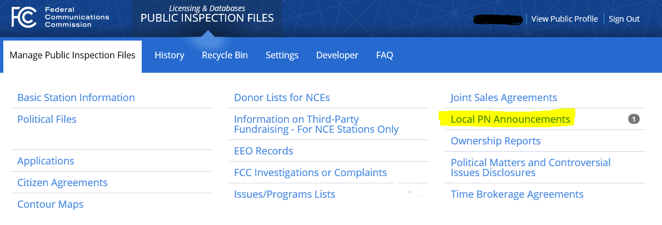

If Your Station Did Not Timely Air the Six Required Post-Filing Announcements . . . . If you are a Virginia television station and did not air the six required post-filing announcements, we recommend you contact your communications counsel immediately, or call the VAB Hotline.
___________________________

Tim Nelson, Editor
BROOKS, PIERCE, McLENDON,
HUMPHREY & LEONARD, L.L.P.
Mark J. Prak
Marcus W. Trathen
David Kushner
Coe W. Ramsey
Stephen Hartzell
Julia C. Ambrose
Elizabeth E. Spainhour
J. Benjamin Davis
Timothy G. Nelson
Patrick Cross
___________________________________
This Legal Review should in no way be construed as legal advice or a legal opinion on any specific set of facts or circumstances. Therefore, you should consult with legal counsel concerning any specific set of facts or circumstances.
___________________________________

© 2020 Brooks, Pierce, McLendon, Humphrey & Leonard, L.L.P.

