 | 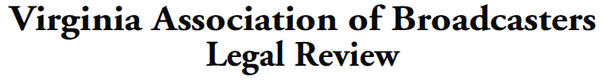
Brooks, Pierce, McLendon, Humphrey & Leonard, LLP  Counsel to VAB • (919) 839-0300 |  |  | 250 West Main Street, Suite 100  Charlottesville, VA 22902 • (434) 977-3716

July 15, 2020

IMPORTANT REMINDERS / DEADLINES

Headlines: July 16, 2020: Deadline to File Proposed Corrections and Comments on Preliminary List of C-band Incumbent Earth Stations
July 27, 2020: Deadline to Verify Accuracy of Information for Fixed 6 GHz Links in ULS; New Rules Permitting Expanded Unlicensed Uses in 6 GHz Band Take Effect
July 31, 2020: Deadline to Upload Carriage Election Contact Information Into OPIF

One Year Warning: July 13, 2021 Deadline for LPTV and Television Translator Stations to Cease Analog Operations and Transition to Digital Operations
_____________________________________

TOMORROW, July 16, 2020: Deadline to File Proposed Corrections and Comments on Preliminary List of C-band Incumbent Earth Stations

We recently wrote to you with a very important “to-do” item for broadcasters with C-band (typically receive-only) earth stations. The FCC’s International Bureau has released a Public Notice (the “Notice”) and a preliminary list (the “List”) of “incumbent” registered/licensed C-band earth stations in the contiguous United States that the Commission deems eligible for reimbursement of reasonable relocation costs incurred in the forthcoming C-band transition. At the same time, the FCC set a deadline of July 16, 2020 (i.e., tomorrow!) for earth station registrants/licensees to comment on the accuracy of the information contained in the List. As explained further below, this means that broadcasters must file any corrections to the List by tomorrow, July 16, 2020, or risk losing reimbursement for their transitioning earth stations.

Brief Background. As you’ll recall, the C-band—which many broadcasters use for the reception of programming—is the swath of spectrum between 3.7 and 4.2 GHz, a large portion of which the Commission will make available via a public auction for new terrestrial wireless uses; the Commission also intends to preserve the continued operation of existing fixed satellite services (“FSS”) during and after the C-band’s transition. Broadcasters with earth stations that will be relocated as part of the upcoming C-band repurposing process will be entitled to various payments for reasonable relocation expenses, provided that the FCC determines such stations are, in fact, “incumbent” earth stations that are eligible to be reimbursed.

What Is a Qualifying “Incumbent” Earth Station? The List is a preliminary accounting of “incumbent” earth stations—i.e., earth stations the Commission currently believes will ultimately be eligible for reimbursement of certain relocation costs. To qualify as such an “incumbent” earth station, your earth station must be an FSS earth station in the 3.7–4.2 GHz band that was (1) operational as of the April 18, 2018, earth station “filing freeze”; (2) remains operational; and (3) meets the following qualifications:

- If the earth station was unregistered or unlicensed before April 18, 2018, an application for registration (for receive-only earth stations) or license (for transmit/receive earth stations) must have been filed by November 7, 2018.

- If the earth station was registered (for receive-only earth stations) or licensed (for transmit/receive earth stations) before April 18, 2018, the registrant or licensee must have either:

  - Certified the accuracy of the registration/license information in the International Bureau Filing System (IBFS) by May 28, 2019; or

  - Filed a modification/update to the registration or license in IBFS during the April 19, 2018–November 7, 2018 filing window; or

  - Filed a timely renewal application for the existing registration or license by May 28, 2019.

So What Do I Need to Do By Tomorrow? Broadcasters with earth stations should check the List as soon as possible. If you believe you have any earth stations that meet the criteria to be an incumbent earth station (and do not appear on the List), you should contact your FCC lawyer and/or email the FCC’s International Bureau staff at IBFSINFO@fcc.gov to alert the FCC of the omission(s). According to the Notice, the subject line of the e-mail should reference IB Docket No. 20-205 as well as the IBFS file number(s) associated with the earth station(s) you believe to have been erroneously omitted from the List.

Using the same process, earth station licensees and/or registrants can request various minor changes to information contained in the List, including minor corrections to the site address and/or geographic coordinates of an existing earth station location or minor changes in operations (e.g., change in an emission designator or, importantly, an antenna no longer in use, or other information that would help inform the satellite operators’ transition plans). Note that earth station registrants/licensees can also notify the FCC of errors or omissions by submitting a filing via the Commission’s Electronic Comment Filing System (ECFS). It would appear, however, that submitting information via email—again, to IBFSINFO@fcc.gov—is the easier approach.
___________________________

July 27, 2020: Deadline to Verify Accuracy of Information for Fixed 6 GHz Links in ULS; New Rules Permitting Expanded Unlicensed Uses in 6 GHz Band Take Effect

In addition to verifying information pertaining to C-band earth stations, broadcasters must also expeditiously verify the accuracy of the information in the Commission’s Universal Licensing System (“ULS”) pertaining to broadcasters’ fixed 6 GHz links. With the Commission’s new rules permitting expanded unlicensed uses in the 6 GHz band set to take effect on July 27, 2020, broadcasters must review and—if necessary—update the information regarding their incumbent fixed 6 GHz links to help guard against harmful interference that may be caused by the new, expanded unlicensed operations.

Brief Background. Back in April of this year, the FCC adopted a Report and Order and Further Notice of Proposed Rulemaking (the “Order”) that expands unlicensed broadband operations in the 6 GHz spectrum band (i.e., 5.925 GHz–7.125 GHz). The Order was a setback for broadcasters, who already have deployed—and rely on—significant electronic newsgathering operations in the 6 GHz band and who had warned the Commission that permitting expanded unlicensed broadband operations in the band could cause harmful interference to those electronic newsgathering operations. For years, broadcasters have used the 6 GHz band for essential broadcast auxiliary services, including video relays and the operation of certain wireless microphones. The Order’s new rules are currently set to take effect on July 27, 2020, notwithstanding the several petitions for reconsideration that have been filed and are pending with the Commission.
So What Do I Need to Do by July 27? The Order’s new rules do provide limited protections to broadcasters by requiring many new, unlicensed users of the 6 GHz band to consult an automated frequency coordination (“AFC”) system prior to deploying operations. The AFC system will use broadcasters’ existing operations to establish “exclusion zones” where new unlicensed devices cannot operate.

However, the AFC system will only be as effective as the licensee data with which it is populated. That data will come directly from ULS and will include transmitter and receiver locations, frequencies, bandwidths, polarizations, transmitter effective isotropic radiated power (“EIRP”), antenna height, and the make and model of the antenna and equipment used.

It is therefore critical for broadcasters to review ULS as soon as possible to ensure that the foregoing information regarding their fixed 6 GHz links is accurate. To the extent actual operations differ from the ULS records, broadcasters may wish to seek to modify those records (quickly) to ensure protection from harmful interference from any other spectrum users. (For example, if frequency coordination is required to remedy incorrect ULS information, then it will likely take at least two weeks to go through the necessary coordination processes.)
___________________________

July 31, 2020: Deadline to Upload
Carriage Election Contact Information to OPIF

Another important regulatory “to-do” item must be completed within the next two weeks: by July 31, 2020, broadcasters are required to upload to their online public inspection files (the “OPIF”) an up-to-date email address and phone number for carriage-related questions. The July 31, 2020, deadline was established by the Commission’s recent changes to the retransmission consent/must-carry election rules and is designed to prepare stations for their upcoming triennial carriage elections, which must be made no later than October 1, 2020.

Brief Background. As broadcasters will recall, last year the Commission jettisoned the requirement that broadcast television stations make their triennial retransmission consent/must-carry elections to MVPDs in written notices sent via certified mail. Instead, the Commission now requires broadcasters to post their carriage elections to their OPIFs. And, significantly, stations will be required to send an email carriage election to an MVPD only when changing carriage election status (i.e., from retransmission consent to must carry or vice-versa).

So What Do I Need to Do by July 31? As part of the new electronic carriage election provisions, both broadcasters and MVPDs must, by July 31, 2020, provide an up-to-date email address and phone number for carriage-related questions and will be responsible for the continuing accuracy and completeness of the information furnished. To fulfill this requirement, broadcasters should input the information into the new field that is populated in their station(s) OPIF(s) titled “Carriage Election Contact Information,” visible near the bottom of the landing page of the station’s OPIF.

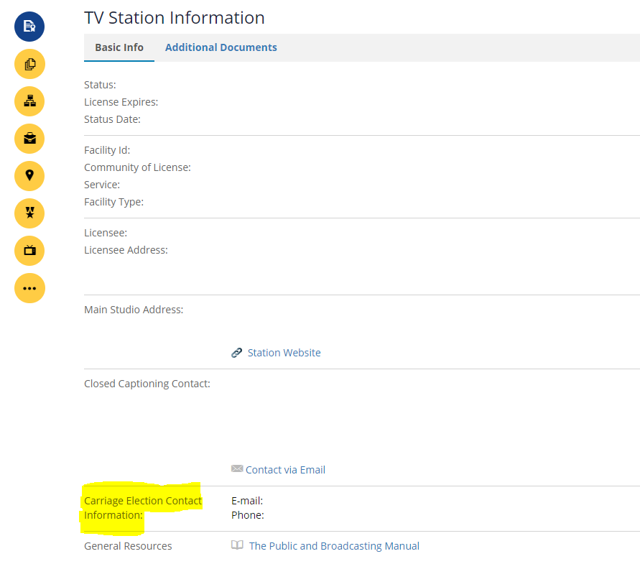

Broadcasters should consider carefully what information they enter into this new field. Options include:

(i) designating a station representative who is knowledgeable about the station’s carriage elections;

(ii) designating a corporate representative who may handle retransmission consent across multiple stations or an entire station group; or

(iii) creating a new email address and obtaining a new phone number that will be monitored by an appropriate representative, such as the individuals referred to in (i) and (ii).

Regardless which route a station chooses, the station must respond to any inquiries received from MVPDs as soon as is reasonably possible. Accordingly, it may be advisable to create a new, carriage-specific email address so that your station does not need to update the foregoing information in the OPIF every time station carriage personnel changes.

Finally, broadcasters should remember that the triennial carriage-election process will look a bit different this year in light of the recent changes. For example, on or before the election (must carry or retrans) deadline each station will be required to upload to its OPIF a single statement outlining all of its carriage elections and, in the case of a change in carriage election from the previous cycle, broadcasters will henceforth need to send email notices to MVPDs with a cc email (courtesy copy) sent to ElectionNotices@FCC.gov. In the coming weeks, we will remind you about the triennial carriage-election process as the October 1, 2020, deadline nears. For now, stations’ primary focus should be on considering which email address and phone number they wish to designate for carriage-related questions and ensuring that information is timely uploaded to the OPIF.
___________________________

One Year Warning: July 13, 2021 Deadline for LPTV

and Television Translator Stations to Cease Analog

Operations and Transition to Digital Operations

By recent Public Notice (the “Notice”), the Media Bureau issued a reminder to low power TV (“LPTV”) and TV translator stations that there is only one year remaining until the July 13, 2021, digital transition date by which stations must terminate all analog television operations. All LPTV and TV Translator stations must terminate all analog television operations by 11:59 PM local time on July 13, 2021, regardless whether their digital facilities are yet operational. The Notice makes clear that no extensions or continuation of analog operations will be permitted past the July 13, 2021 deadline—stations that have not yet constructed a digital facility by the deadline must therefore remain silent until construction is completed.

Additional Deadlines. The Notice also outlines several other important deadlines broadcasters operating LPTV and TV translator stations should keep in mind:

- March 13, 2021, is the deadline by which LPTV and TV translator stations experiencing delays in completing their digital facilities may seek one last of extension of time of their digital construction permits. Any such extension request must be for no more than 180 days and must include an exhibit demonstrating that (1) the failure to meet the construction deadline is due to circumstances that were either unforeseeable or beyond the licensee’s control and (2) the licensee’s has taken all reasonable steps to resolve the problem expeditiously. Examples of extension-qualifying circumstances include, but are not limited to: (a) delays in obtaining necessary zoning; (b) inability to obtain equipment; or (c) financial hardship.

After March 13, 2021, additional time to construct will be much more difficult to obtain, and can only be sought either under a waiver or the FCC’s “tolling” rule, the latter of which requires a demonstration that specific circumstances outside of the licensee’s control—e.g., acts of God or delays due to administrative or judicial review—prohibited construction. Notably, financial hardship is generally not a valid basis to trigger application of the “tolling” rule.

- May 1, 2021, is the recommended deadline by which LPTV and TV translator stations should submit any applications or filings requesting last-minute technical changes (e.g., minor change applications or requests for special temporary authority). This recommended filing deadline is to allow sufficient time for staff processing of any such requests.

- July 13, 2021, aside from being the deadline by which LPTV and TV translator stations must cease analog operations, is also the deadline for licensees of eligible full power television stations to file for digital-to-digital replacement translator (“DTDRT”) service to recover lost digital service area that resulted from the repack.

Additional reminders. The Notice also reminds stations of several important rules and obligations that could or will arise during the transition, several of which we note below.

- Silent STA Requests: For stations that experience periods of silence during the transition, several FCC rules may come into play. When station operations are suspended for more than 10 days, the station must notify the Commission no later than the tenth consecutive day of station silence. And stations may not suspend operations for a period of more than 30 days without receiving specific FCC authority via a Silent STA request submitted in LMS. Finally, broadcasters need to be keenly aware of the fact that the license for a station that remains silent for any consecutive 12-month period will automatically expire.

- Surrender Versus Flash Cut of Analog Channels: LPTV and TV translator stations have two options for completing their transition to digital-only operations, either (1) “flash cutting” their existing analog facility to digital or (2) surrendering their analog channel and continuing to operate on a digital companion channel. Stations should follow the specific processes outlined in the Notice (which we encourage you to discuss with your FCC counsel) so that they are no longer operating with analog emissions by no later than July 13, 2021.

- Viewer Notifications: LPTV and TV translator stations are required to notify their viewers of the planned transition to digital, using notifications that are—in each licensee’s good faith—appropriate in frequency, length, and content. Note, however, that for stations with the technical ability to locally originate programming, such notifications must be provided (1) on the air and (2) at a time when the highest number of viewers are watching. On the other hand, in the case of stations that lack the technical ability to locally originate programming, or conclude that airing of viewer notifications would pose a hardship, such stations may notify viewers by some other “reasonable means,” such as newspaper publication or by contacting their originating station to relay a crawl or service advisory to the affected communities.
___________________________

Tim Nelson, Editor

BROOKS, PIERCE, McLENDON,
HUMPHREY & LEONARD, L.L.P.
Mark J. Prak
Marcus W. Trathen
David Kushner
Coe W. Ramsey
Stephen Hartzell
Julia C. Ambrose
Elizabeth E. Spainhour
J. Benjamin Davis
Timothy G. Nelson
Patrick Cross
___________________________________
This Legal Review should in no way be construed as legal advice or a legal opinion on any specific set of facts or circumstances. Therefore, you should consult with legal counsel concerning any specific set of facts or circumstances.
___________________________________

© 2020 Brooks, Pierce, McLendon, Humphrey & Leonard, L.L.P.

